Speech Recognition System for A Voice Controlled Robot with Real Time Obstacle Detection and Avoidance

¹Yasir Ali Memon, ²Imaaduddin Motan, ³Muhammad Ali Akbar, ⁴Sarmad Hameed, ⁵Moez ul Hassan
SZABIST University
Karachi, Pakistan
¹yasirali22@hotmail.com, ²imaadmotan@gmail.com, ³m.aliakbar989@gmail.com , ⁴sarmad.hameed@szabist.edu.pk , ⁵moez.hasan@szabist.edu.pk.

Abstract
Speech Recognition is a technology which allows the processing of a speech input to text and is speaker independent. This allows it to be used in numerous applications ranging from digital assistants to controlling machinery. This paper proposes a strategy which can be used in controlling a robotic vehicle through connected speech input. The speech recognizer platform will be an Android smartphone which communicates with the robot using Bluetooth Connectivity. This method allows for efficient recognition and smooth data transfer. Additionally the robot will also have the capability to detect obstacles and inform the user to use a different command. Our proposed technique will be useful for applications such as assistive robots for people with disabilities or in industrial applications such as work robots.

Keywords — android, bluetooth connectivity, robot, speech recognition, ultrasonic, voice control.

- Introduction
Robots are a package of systems which include mechanical, electrical, computing and automation fields of technology which can be used to perform various tasks in industrial and domestic use. And with increasing developments in this field robots can now be controlled with lesser direct human intervention to achieve a more natural interaction with machines. A way to accomplish such is to control a robot via voice commands. This allows the user to free up their hands and work on other tasks. Some basic applications of robots utilizing voice recognition are to support people with disability, executing preset commands etc. To process the voice commands a simple and efficient method is to use a smartphone. Smartphones are powerful devices capable of performing many functions similar to a computer. With their own independent operating system and internet connectivity they are increasingly being utilized in many applications. One of the major features that we shall make use of is the integrated Bluetooth. This will allow the phone to communicate with the robot. Several Operating Systems are used for smart phones but the most common one is the Android OS developed by Google Inc. Its flexibility and ease of use make it an ideal interface for robotic application. These android related systems are very efficient for developing applications throughout the world.
Bluetooth technology exchanges data over a short range but is very proficient way of communicating between two devices such as microcontroller and a smart phone. Data packages are sent and received through shortwave radio signals. It is essential for robots to take commands without any delay so we have used Bluetooth as the main communication method. In daily life such robots can be used for navigation and for control guidance to a certain position.
The robot can either maintain preset linear speed or can be have variable speed on flat surfaces. The voice recognition is maintained with help of a micro controller; an Arduino (MEGA). Five basic commands are used to steer the robot that are forward, right, left, reverse and stop to guide the robot. Building on these, a few more commands allow the robot to change speed or perform a particular movement. To detect and avoid obstacles an ultra-sonic module is implemented, programmed to stop the robot if there is any obstruction in its way, and inform the user to use another voice command. Ultra-sonic sensors use sound wave transmitters and receivers to record the echo time and use that to calculate the distance.
MIT App Inventor 2 was used for developing an android application. This is a tool which uses block a programming technique so that even beginners can experience android app development. It was essential to develop an application to establish a wireless communication over a certain range via Bluetooth.

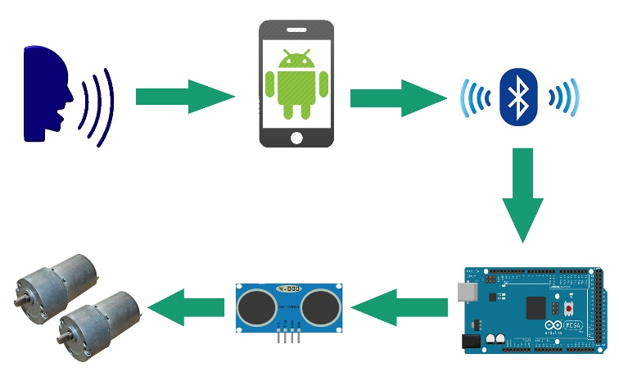
Figure 1: Block Diagram

With the help of the two basic functions which are voice recognition and Bluetooth communication the robot can be used for variable purposes and application commercially and domestically as mentioned above. It is vital to create more technological advances in voice recognition systems to enhance the efficiency of such robots.
- Controlling of Robot
Continuing on from the previous section, the robot will receive the commands in text form. This is done by the connected Bluetooth receiver at the robot end. Initially the robot will wait for an incoming connection. When available, the text will be parsed character by character to the robot. The Arduino will then build the characters into a single word. A small delay of 100 milliseconds is implemented in building the word, so as to prevent overwriting or loss of any character. Once the command has been received the Arduino then compares the text to the preprogrammed instruction set as follows:
- Slow Forward: Activates both motors and Moves Robot forward at low speed.
- Fast Forward: Activates both motors Moves Robot forward at full speed.
- Slow Backward: Activates both motors and Moves Robot backward at low speed.
- Fast Backward: Activates both motors and Moves Robot backward at high speed.
- Sharp Right: Activates both motors (Right Motor Reveres and Left Motor forward) and makes a 90 degree point turn.
- Slow Right: Activates left motor and makes a 90 degree wide turn.
- Sharp Left: Activates both motors (Right Motor forward and Left Motor reverse) and makes a 90 degree point turn.
- Slow Left: Activates right motor and makes a 90 wide turn.
- Zigzag: Activates both motors alternatively to move forward in a zig zag pattern.
- Stop: Deactivates both motors.

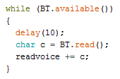
Figure 2: Code for checking and reading bytes from Bluetooth

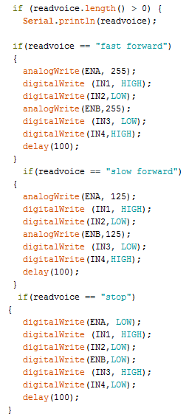
Figure 3: Check if string has been received and execute command

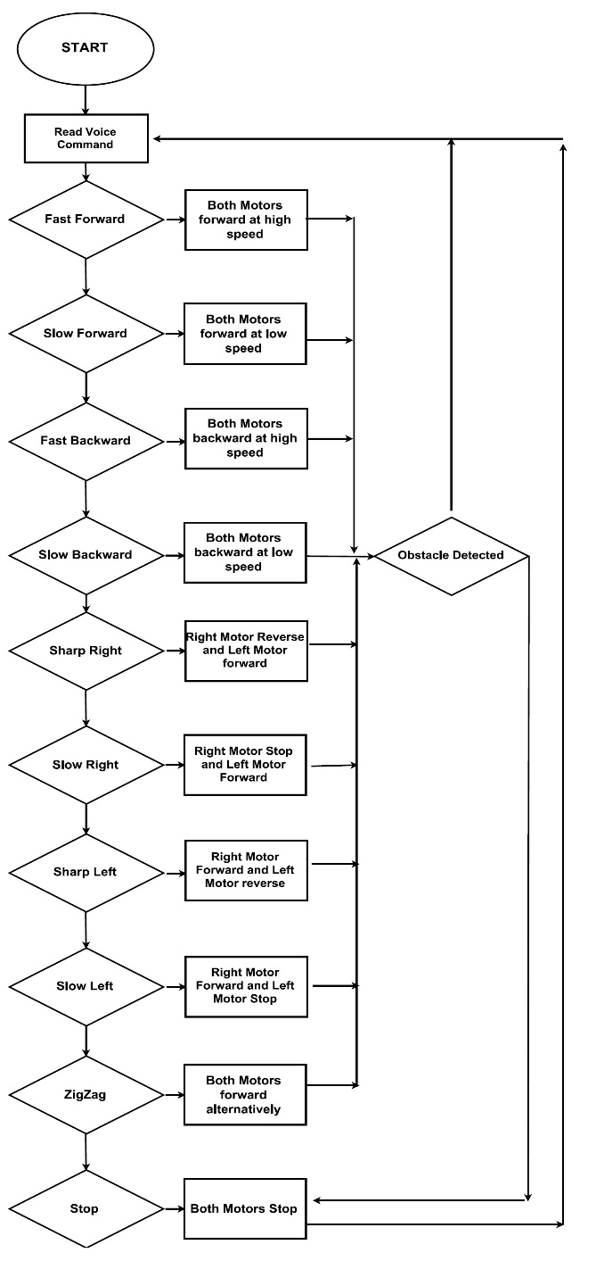
Figure 4: Flow Chart of command execution

- Hardware

Arduino Mega
Arduino mega is a microcontroller board and it is based on the ATmega1280. It contains 54 digital input and output pins including 14 PWM pins, 16 analog inputs, crystal oscillator of 16MHz, a USB connection, ICSP header, and a reset button. The Arduino integrated development environment (IDE) is a cross platform application using Java. It is used to write a code or program and upload programs to the board.
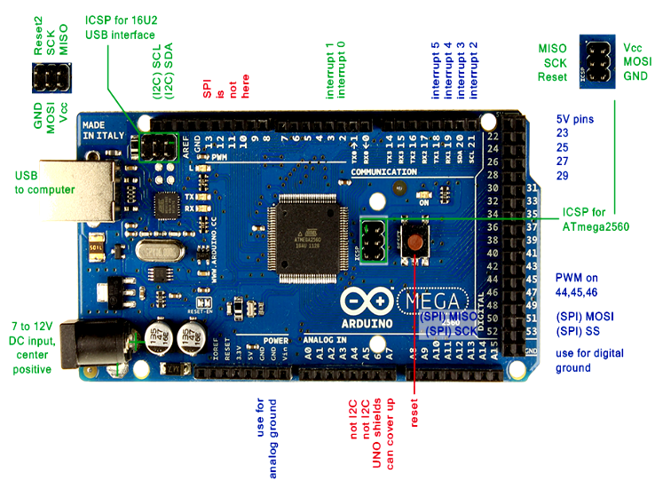
Figure 5: Arduino Mega

HC-05 Serial Bluetooth Module
Bluetooth is a wireless technology that can easily interconnect mobile phones, PDA, and personal computer with each other using a short-range wireless connection. Using a Bluetooth module chip, wireless Bluetooth communication can be established between two devices using MAC address as each device has its unique MAC address. HC-05 module shown in Figure is an easy to use Bluetooth Serial Port Protocol module for a wireless serial connection setup. This module is based on the silicon radio BC417 2.4 GHz Bluetooth chip with CMOS technology and it uses an external 8 Mbit flash memory. HC-05 module operates on 3.3V power supply.
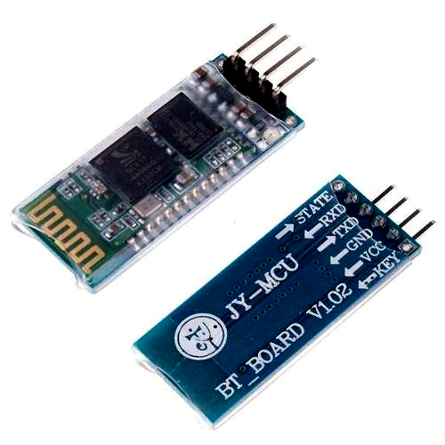
Figure 6: HC-05 Bluetooth Module

Ultrasonic Sensor
The HC-SR04 ultrasonic sensor uses sonar to measure distance from an object. It provides 2cm - 400cm non-contact measurement function, and the ranging accuracy can reach up to 3mm. The modules includes ultrasonic transmitters, receiver and control circuit.

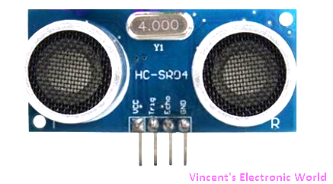
Figure 7: Ultrasonic Sensor

L298 H-Bridge Serial Motor Driver
This dual bidirectional motor driver is based on L298 chip. It contains two ‘H bridges’ which are high voltage and high current full bridge drivers that can drive two DC motors. L298
motor driver can independently control two motors of up to 2A each in both directions. L298 IC amplifies an output current as the current from the microcontroller is not enough to drive the DC motor directly so L298 chip is used for this purpose. It contains two enable inputs pins which can be directly control from Arduino to enable or disable the device independently of the input signal. PWM signal are send from Arduino to motor driver to change the speed of motors by varying the PWM signals.
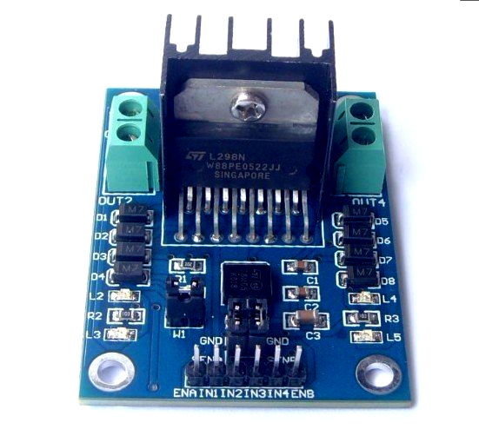
Figure 8: L298 H-Bridge Motor Driver
- Software

Android App
As mentioned previously the voice commands to the robot are processed via an android application and transferred via Bluetooth. A decision to use an Android OS interface as the speech processing platform was made, due to its flexibility and numerous features. Also it allows an easy and reliable connection with the Google Speech processing libraries for smooth and accurate speech recognition. To do this we constructed an application using MIT App Inventor 2.
MIT App Inventor 2 is a tool which allows easy creation of android Apps via drag and drop block programming. This provides people with little to no experience in Java programming, a way to develop simple applications to suit their purposes.
Moving to our App; once the app launches the user has to connect to the robot via Bluetooth. Once connected the status of the application changes to ‘connected’. Then clicking the microphone button opens up the speech recognizer. The recorded audio is processed after which the transcribed text is displayed and sent to the connected Bluetooth in the form of a string or character array.

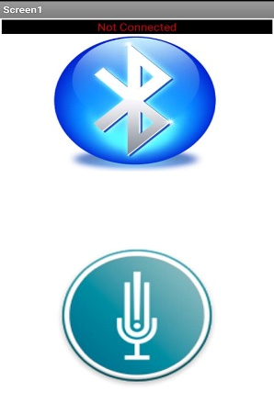
Figure 10: Android Application Screen

- Software Architecture
The software architecture design diagram in Figure 12 shows how each software part integrates with the robot.
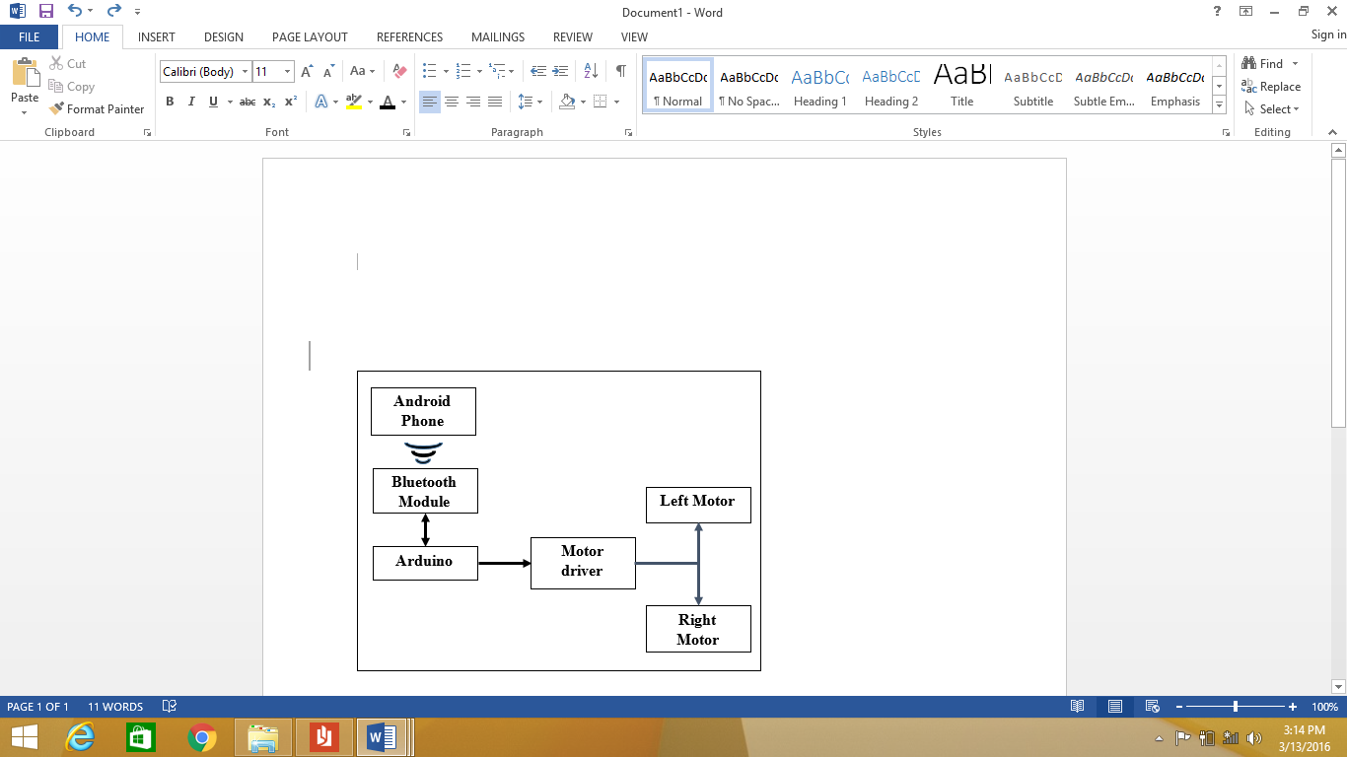
Figure 9: Software Architecture

- Hardware Implementation

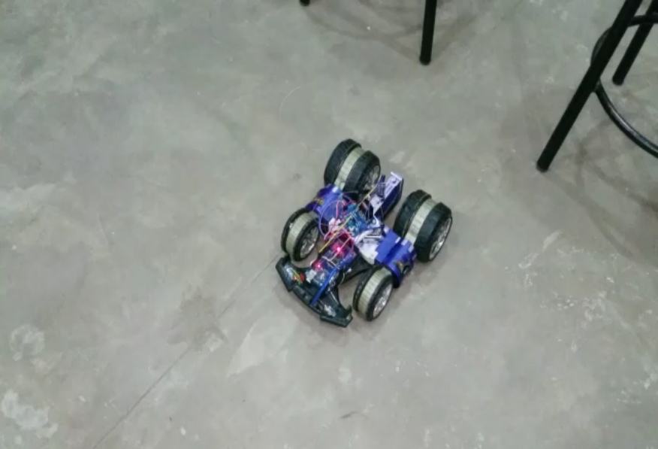
Figure 10: Robotic Vehicle

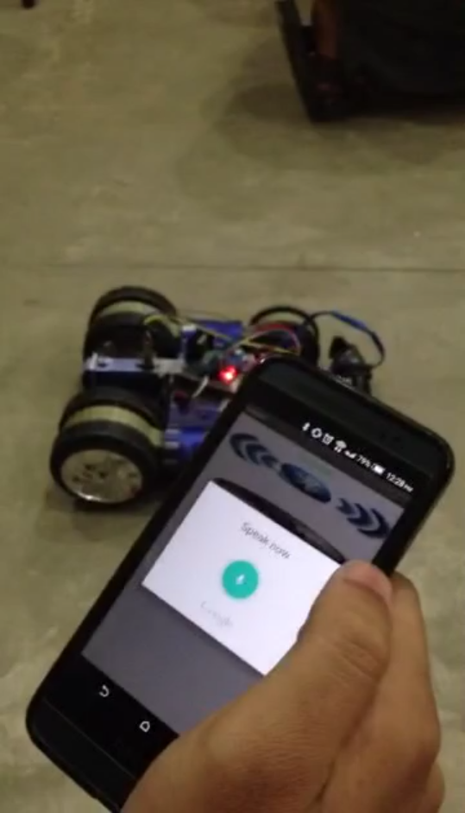
Figure 11: Controlling a Robot Using Android App

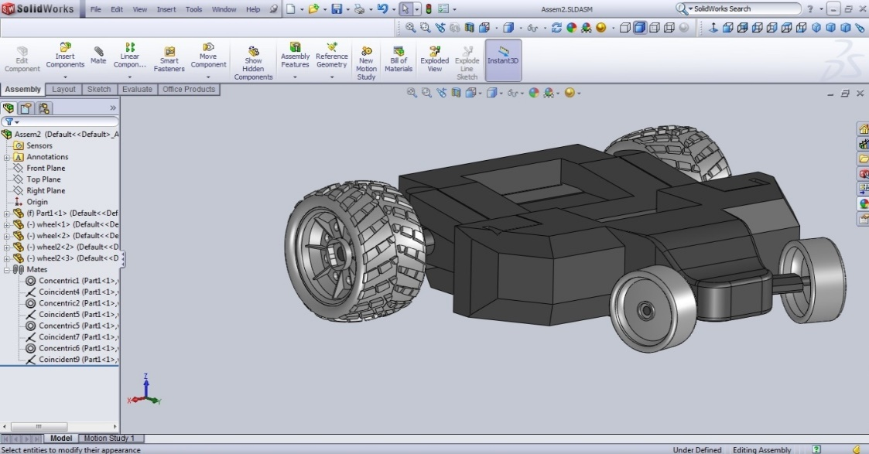
- Cad Cam Model
Figure 12: CAD Model of Voice Controlled Robot
The structure of our project as shown in Fig 15 is based on a RC car which includes the 2 DC motors. The body is made of rigid plastic while the tires are formed from soft rubber. The rear wheels have larger diameter as compared to the front wheels. Shocks are attached to the rear tires to reduce vibration and also to assist in creating more friction on inclined surfaces. The rear lower end has a compartment to house for the battery pack.
The dimensions of the car are 12” by 10” by 4”. The two DC motors, connected to the rear tires via a gearing mechanism, are operated through a Dual motor H Bridge L298 driver, which is powered by the 9V battery.
Both motors are synchronized to run at the same speed. The DC motors and motor driver IC are placed on the upper body. Furthermore, the motor driver IC provides a 5V power supply to the Arduino which is the main decision making and controlling unit of the car.
The Arduino is also positioned on the top portion of the car. An ultrasonic sensor is attached at the front, which is used for obstacle avoidance, and the Bluetooth module is attached to lower right side of the car body.

- Application and Future Work
This system can be implemented in various applications such as:
- Indoor assistive robots which will navigate around to pick up objects from one place and place them at another using speech commands technique.
- Surveillance applications to send live feed from camera and track down an objects.
- Industrial Robots
- On board digital assistants for automobiles.

- Conclusion

In a nutshell we can conclude that voice controlled robots can certainly be a future market for many industrial and domestic purposes related to automating daily tasks.
After several runs and tests our proposed method of Bluetooth communication worked efficiently with an acceptable time delay. The connections between the microcontroller and Bluetooth worked quite well with a few errors in recognition of voice commands.
We used both GSM and WIFI based internet connectivity for the application to recognize the commands and link it to Arduino. But for future modifications we can create an offline system for the application to recognize voice and send it back to microcontroller. A few modifications in the android based application can result in a much more clarity of voice recognition.
References
[1] | A. K. and R. C. , "Voice Controlled Robot," INTERNATIONAL JOURNAL OF INNOVATIVE RESEARCH IN TECHNOLOGY, vol. 1, no. 11, pp. 338-344, 2014.
[2] | A. D. A. P. S. N. and L. R. , "Three way controlled android Smartphone based," International Journal of Advanced Research in Computer and Communication Engineering, vol. 4, no. 9, pp. 212-216, September 2015.
[3] | K. K. and D. J. S. , "ARDUINO BASED VOICE CONTROLLED ROBOT," International Research Journal of Engineering and Technology (IRJET), vol. 02, no. 01, pp. 49-51, March 2015.
[4] | J. and D. , "Home Automation and security system using android adk," International journal of electronics communication, 2013.
[5] | "Arduino," [Online]. Available: www.arduino.com. [Accessed 2015].
[6] | S. N. and S. , "Design of a Voice Controlled Robotic Arm for Picking and Placing an object" IOSR Journal of Engineering, vol. 2(4), pp. 670-673, April 2012.

